3-D Printed Jewelry & accessories

(**this are notes erase or replace if you want to comment on something**)

**Business Idea**— (change a bit here)

To provide nice and affordable jewelry for all ages at an accessible price. Provide a nice design which will attract people while keeping the price down. Allow customers to send in either a custom design they want to be created and have it done for them as specifications. Custom design will provide a more sentimental value and uniqueness as it would be a one of a kind.

We not will only provide for luxurious piece but also affordable ones that will make those who buy them be happy.

**Competition**— (I think what Stephanie had in the PPT is fine… just need to see as the company I put there Pugster is the only one with the same business idea in the area… well this need to be discuss a bit more)

Looking around the area, our main competition would be Pugster Inc. as they provide cheap and affordable jewelry to the public.

According to Porter’s competitive forces model, we are going to use differentiation of product, cost effectiveness, and improve price/performance. Although the Pugster Inc. aims to sell the cheap jewelry, our products are also sold at a low price with the complete unique design that can not be found in anywhere, also, customers could enjoy the experience of designing their own jewelry(differentiation of product). Since our products are produced after customers provide their requirements, all materials would not to be wasted (cost effectiveness). As long as our business goal is accepted by public with more and more customers attracted by our products , we could hire creative designers to improve our performance and provide good sales (improve price/performance)

**Role of IS**—

The use of information system will be to Collect Data and applying by understanding the demography of people that spend certain amount of their income in jewels/jewelry. Get information about the competition and how they perform around that area. Collect data of the expenses require to maintain the business. The need of the client and what they would prefer to see in this store.

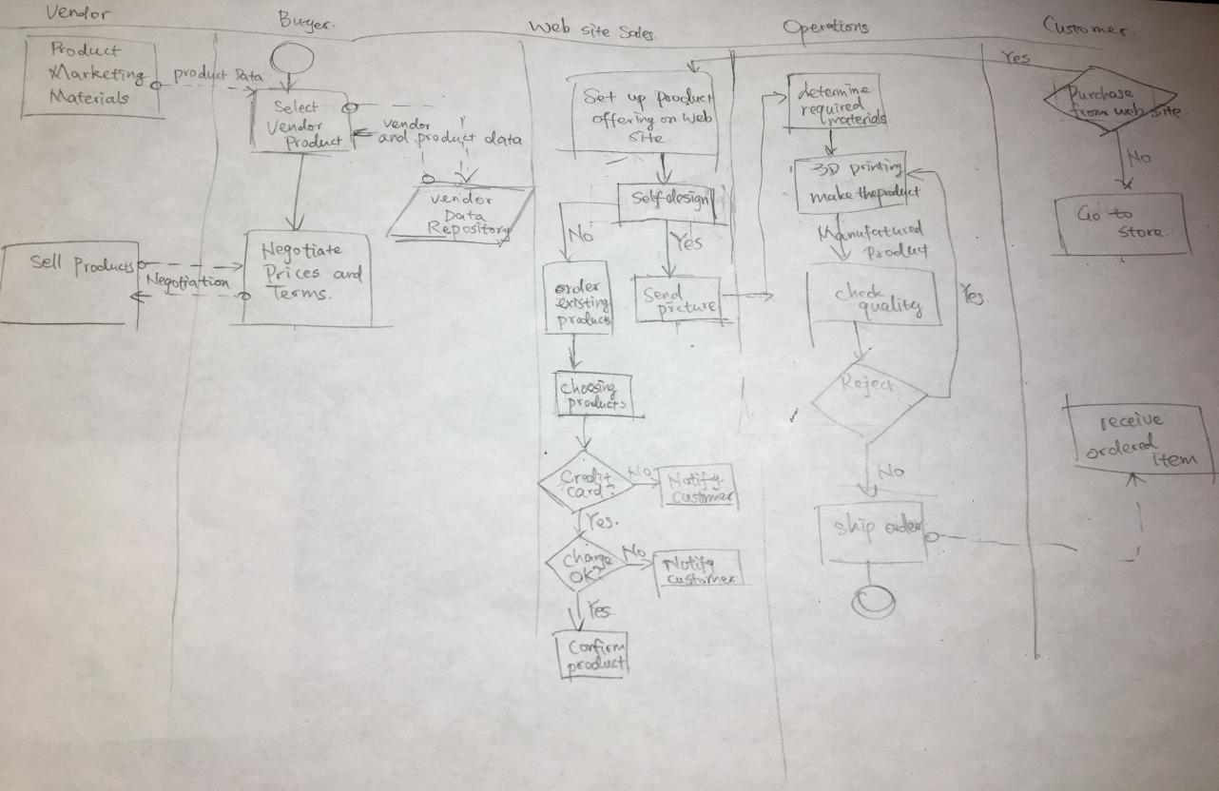

(Xue Feng)

**Revenue—**

We will generate revenue through, up or down scaling the quality of the metals used in our jewelry. For example, if someone wants a ring since we 3-D print the Jewelry, depending on the customers’ need or want they can choose to have the rings band to be made from either silver, gold, or white gold on the spot. This allows us to reach a larger demographic of customers allowing us to generate high sales. Another way to generate revenue is if the customer wants to add either gems or diamonds to their jewelry they can then talk to our jewelers for a more personal and tailored experience when designing their jewelry, the way they want. By doing this it also allows us to reach the luxury market of jewelry to help generate revenue.

**Customers— (yeah, I remember saying that… I add it something there but you guys should see it)**

Maybe for our customers we can age range from 22- 40 years old males and females or somewhere in between. Because people 40 and above rather have real jewelry than some fashion style ones. (I believe you said something like this Miguel.) I think our target customer should be 22-40 years females because we are hard to stimulate consumption on males but we need to try our best to fast spread our products into crowd and make people be familiar with 3-D printed jewelry at the beginning.

The target customer would range from ages 12 – 40 years old males and females. Reason behind this would be because in the case of young people, they then to go with the fashion and trend of the moment. So, for them we can provide accessories that follow the current trend for and affordable price. For young adults and older besides the affordable designs, more higher quality would be at their reach as well as the ability to request custom design unique to for the individual. Also, our target customer would mainly be in middle and high income class because customers in lower class probably would not choose to spend money on trying to have 3-D printed jewelry in hand.

**Location Analytics I—**

looking at the median average disposable income. This will allow us to know where it would be better to open a store. Also, setting not getting to close to others keeping a good distance so our business doesn’t conflict with the others.

**Location Analytics II—**

**(**This is a not well done sample just a screen shot… need to work it out more…trying to understand how to use it… I should watch some videos.) This use the Ave disposable income and location of Jewelry stores to see where in Pasadena would be a good idea.

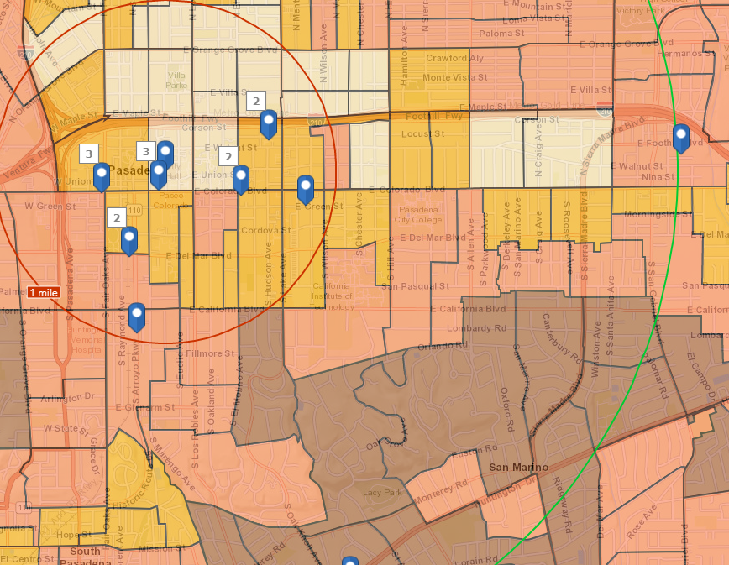

**Location Analytics III—**

In this map shows results of where in Pasadena people spend the most on watches. I’ve pin pointed a few locations within 1, 3, and 5 miles radius. There is one large area of the map that is red, but I believe those are people who live near the mountains and that’s is no place where to set up shop.

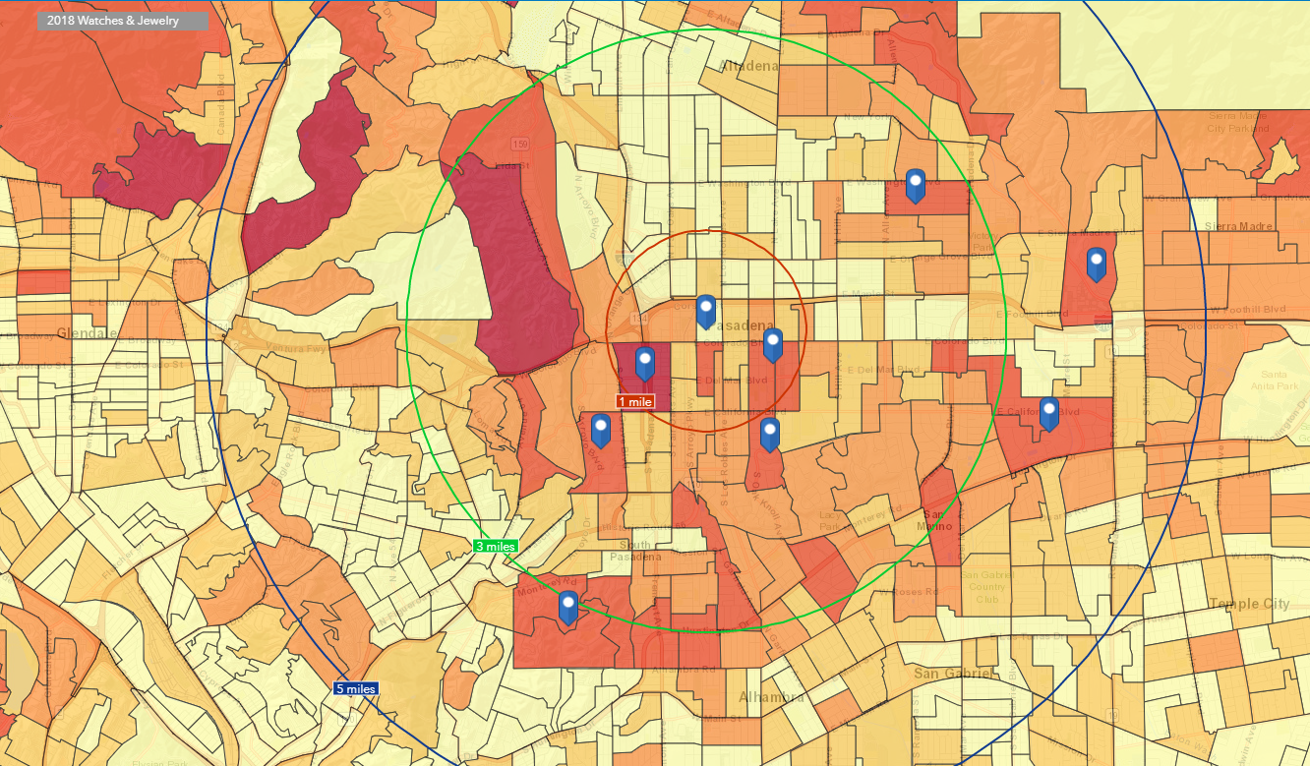

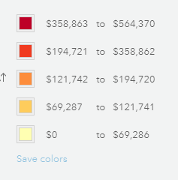

**Location Analytics IV—**

**Location Analytics V—**

**Location Analytics VI—**

**Marketing Strategy—**

**Messaging Strategy—**

**Profitability—**

**Conclusion—**

**Three Wows—**

**Stores a bit of information**

**Location: *Pasadena***

Altadena Watch Co—Repair and services for watch and Jewelry-- sales volume $837,000

Jewels by Rochella—No on google maps nor information regarding about them-- sales volume $558000

Pasadena Jewelry—sales volume $558,000-

Valia’s Jewelers--Repair and custom-design, also watch repairs—Buy jewelry and antiques…resellers. -- sales volume $837000—( <https://valiasjewelers.com/>)

Bassano Jewelry—25 yrs. old store—BAO shows it on the map, but website shows Manhattan-- sales volume $274,000

Pugster Inc—Cheap jewelry—Sales Volume $6,972,00—Site doesn’t work well as of now (<http://www.pugster.com/>)

La Memoire Fine Jewelers— Sales Volume $279,000—more into the expensive type jewelry (need more research)

Rainbow Jewelry-- Sales Volume $97,000

**Not in BAO.Arcgis**

Minassian Jewelers—Private store-single business location-1994-